**Day 46**

**What to do?**

Learn how to train the CNN models on grey scale images. Try applying CNN’s to project #3 and #4 and see how performance changes.

**Project 3 – handwritten classification:**

Network architecture:

ConvNet

24 x 24 x 32

Input

28 x 28 x 1

F = 2, s = 1, p = ‘valid’

F = 5, s = 1, p = ‘valid’

F = 2, s = 1, p = ‘valid’

ConvNet

8 x 8 x 32

F = 5, s = 1, p = ‘valid’

Maxpool

12 x 12 x 32

128 x 1

Fully Connected

512 x 1

Maxpool

4 x 4 x 32

Flatten

10 x 1

Fully Connected

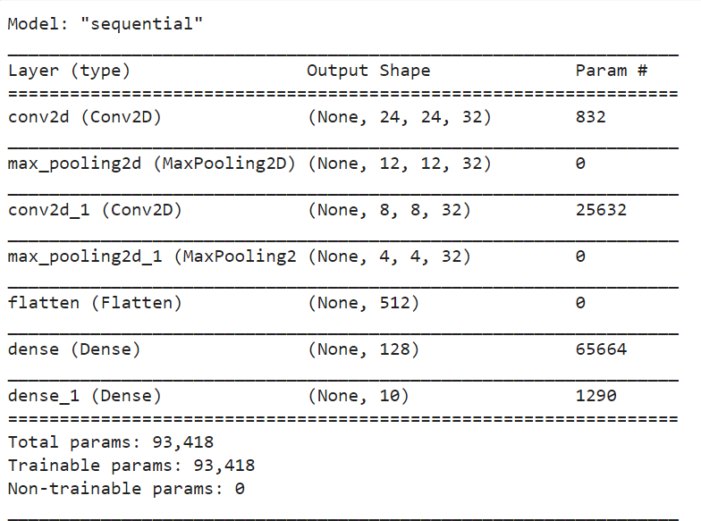

Model summary

Model:

All the layers have ReLU activation function except the output layer, as it has softmax activation function. The model is then compiled with Adam optimizer with sparse categorical cross entropy loss and is evaluated by accuracy. The model is then trained with 10 epochs and batch size of 500.

Results:

* Training accuracy: 98.89% (previously -> 98.14%)
* Testing accuracy: 98.56% (previously -> 97.25%)

**Project 4 – CIFAR 10:**

Network Architecture:

Input

32 x 32 x 3

F = 5, s = 1, p = ‘same’

ConvNet

32 x 32 x 32

F = 2, s = 1, p = ‘valid’

Maxpool

16 x 16 x 32

F = 5, s = 1, p = ‘same’

ConvNet

16 x 16 x 64

F = 2, s = 1, p = ‘valid’

1024 x 1

Fully Connected

2048 x 1

Flatten

Maxpool

4 x 4 x 128

Maxpool

8 x 8 x 64

F = 5, s = 1, p = ‘same’

ConvNet

8 x 8 x 128

F = 2, s = 1, p = ‘valid’

10 x 1

Fully Connected

512 x 1

Fully Connected

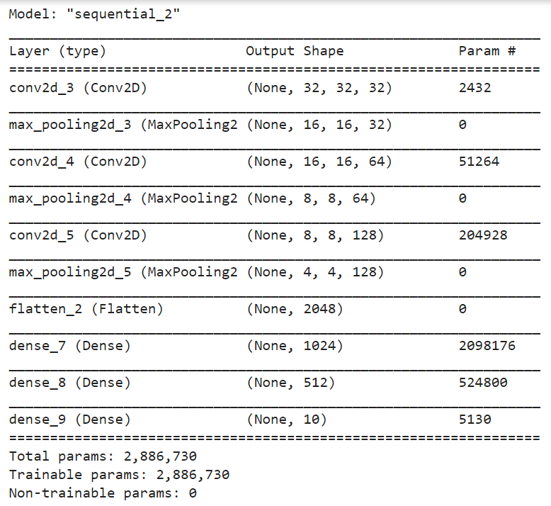

Model Summary

Model:

All the layers have ReLU activation function except the output layer, as it has softmax activation function. The model is then compiled with SGD optimizer with sparse categorical cross entropy loss and is evaluated by accuracy. The model is then trained with 22 epochs and batch size of 100.

Results:

* Training accuracy: 94.23% (previously -> 60.86%)
* Testing accuracy: 70.77% (previously -> 53.94%)

**Note:**

The third dimension in the ConvNets and Max pools used are the number of filters being used in the layer, which play a huge crucial role in detecting multiple features at the same time.